USDA Foreign Agricultural Service
GAIN Report

Template Version 2.09

Global Agriculture Information Network

Required Report - public distribution
Date: 7/19/2005
GAIN Report Number: JA5038
JA5038
Japan
Food and Agricultural Import Regulations and Standards
Agricultural Biotechnology Report
2005

Approved by:
Clay Hamilton
U. S. Embassy
Prepared by:
Tetsuo Hamamoto

Report Highlights:
Report Highlights: Japan, as one of the largest importers of US agricultural biotechnology products from the U.S., has approved 61 biotech events for food, 38 for feed and 50 for planting. Japan does not produce any biotech products commercially but does have several products under development. Japan ratified the Biosafety Protocol in November 2003 and has implemented mandatory biotech labeling on certain foods containing biotech derived ingredients. In general, biotech products are not well received by the Japanese food industry or consumers.

Includes PSD Changes: No
Includes Trade Matrix: No
Annual Report
Tokyo [JA1]
[JA]
Table of Contents
SECTION I. EXECUTIVE SUMMARY 3
SECTION II. BIOTECHNOLOGY TRADE AND PRODUCTION 3
Biotechnology crop production in Japan 3
Biotech crop development in Japan 3
Import of biotech crops 4
SECTION III. BIOTECHNOLOGY POLICY 4
Regulatory framework of agricultural biotechnology 4
Approved biotechnology products 7
Biotechnology products under field trials 11
Safety approvals of stacked events 11
National policy on coexistence between biotechnology and non-biotechnology plants 12
Local government regulations on coexistence 13
Labeling policy for biotechnology products 13
Monitoring of “Biotechnology” or “Non-biotechnology” labeled foods 15
Monitoring for unapproved biotechnology events 15
Implementation of requirements for export of biotechnology products (living modified organisms, LMOs) under the Biosafety Protocol 16
SECTION IV. MARKETING ISSUES 16
SECTION V. CAPACITY BUILDING AND OUTREACH 20
SECTION VI. REFERENCE MATERIALS 21

SECTION I. EXECUTIVE SUMMARY

Japan is one of the largest importers of U.S. agricultural products, importing around 16 metric tons of corn and 4.5 metric tons of soybeans, two major biotechnology plant products, from the U.S. per year. The Japanese government has taken extensive measures to address regulatory and public concerns; including biotech labeling, mandatory safety food and feed review systems as well as domestic regulations pertaining to the Biosafety Protocol based environmental review system. Japan ratified the Biosafety Protocol on November 21, 2003.

The Ministry of Health, Labor and Welfare (MHLW) is responsible for food safety assurances of biotechnology products, while Ministry of Agriculture, Forestry and Fisheries (MAFF) are in charge of feed and environmental safety. The Food Safety Commission (FSC), a risk assessment government body established in July 2003, performs food and feed safety risk assessment for MHLW and MAFF. Japan has approved 61 biotechnology events for food, 38 for feed and 50 for planting. Import of biotechnology events that have not obtained the necessary approvals is strictly prohibited.

Japan is not commercially producing biotechnology plants. A number of public research institutes are carrying out research on the development of plant biotechnology but has not progressed to the field trial stage because of strong consumer concern over biotech products. The private industry is generally limiting its research to the basic level but one company has developed a uniquely colored (blue) carnation but it is grown abroad and imported into Japan.

Japan requires biotech labeling on food products in which traces of biotechnology derived DNA or protein is found. Food manufacturers of those subject to the labeling, without exception, request U.S. suppliers to provide non-biotechnology products based on IP handling. To be labeled as non-biotech, documentation of IP handling is required. Many manufacturers of foods outside the labeling requirement, such as oil, utilize biotech products, however many others such as the end users of corn sweeteners, often request non-biotech products. These end products are then labeled as non-biotech as a marketing tool. The Japanese food industry and the public are reluctant to accept agricultural biotechnology products. This situation can change over take time by educating the consumer to the safety and benefits of biotechnology. The availability of biotech products with consumer benefits will also help speed acceptance.

SECTION II. BIOTECHNOLOGY TRADE AND PRODUCTION

Biotechnology crop production in Japan

There is no substantial commercial production of biotech crops in Japan. There had been a few farmers “experimentally” growing biotech soybeans in Japan in order to confirm their benefits but they terminated their experiments before the crops flowered in order to avoid concerns about cross contamination from surrounding farmers and agricultural coops who oppose biotech crops. Some localities, including the Hokkaido Prefecture have passed resolutions banning all biotech crop production.

Biotech crop development in Japan

Japan is one of the leading countries in the world in the field of biotech research. A number of public research institutes are actively engaging in plant and industrial biotech research and development. However agricultural biotechnology severely lags behind and there are no new food products in the pipeline for commercialization because of strong anti-biotech concerns among consumers Japan. Ongoing research includes the introduction of fungal resistance and pollen allergy suppressing traits into rice. Most of this research is at the early experimental stage and has not progressed to the field trial stage. Taking into consideration the time required to obtain necessary regulatory approvals, it will be years before these products can commercially available. Private industry is generally limiting its research to the basic stage. A uniquely colored (blue) carnation developed by genetic recombination is commercially available by Suntory Co. but it is grown abroad and imported into Japan.

Import of biotech crops

Japan is one of the largest food importers in the world with around 40% of its food being imported (on an energy supply base). Japan particularly relies heavily on imports for corn and soybeans, two major biotech crops produced in the U.S. Japan also imports canola mainly from Canada, which is a major biotech crops produced in Canada.

In order to avoid having to label foods as “ containing biotech” almost all retailers require that food use corn and soybeans be supplied as IP handled non-biotech products. The US supplies about 95% of Japan’s 16 million MT of corn imports per year. Corn for feed consisting accounts for 12 million MT of the total 16 million MT, which is bulk general corn not segregating biotech corn events with the remainder being non-biotech corn for food uses.

For soybeans, Japan imports about 4.5 million MT per year that includes 3.5 million MT from the U.S. Around 3.5 million MT of soybeans are used for crushing annually. Since vegetable oil is exempted from the labeling, almost all of the soybeans imported for crushing are bulk general shipments not segregating biotech products. The soybean food industry (tofu, etc) demands soybean importers supply non-biotech food beans to be used as raw ingredients alongside the 0.2 million MT of domestically produced non-biotech soybeans.

SECTION III. BIOTECHNOLOGY POLICY

Regulatory framework of agricultural biotechnology

In Japan, commercialization of biotech plant products requires environment, food and feed approvals. Four ministries are mainly involved in the regulatory framework for agricultural biotechnology; Ministry of Agriculture, Forestry and Fisheries (MAFF), Ministry of Health, Labor and Welfare (MHLW), Ministry of Environment (MOE), and Ministry of Education, Culture, Sports, Science and Technology (MEXT).

Those ministries act as a secretariat in the regulatory framework to obtain appropriate ministers’ approvals. Risk assessments and safety evaluations are performed by each ministries’ advisory committees and scientific expert panels. The scientific assessments and evaluations are performed by the scientific expert panels, which mainly consist of researchers of universities and public research institutions. The decisions by the expert panels are reviewed or consulted by the advisory committees whose members include technical experts and opinion leaders from a broad scope of interested parties such as consumers and industries. The advisory committees report back the decision to the responsible ministries.

As Japan ratified the Biosafety Protocol in November 2003, Japan enforced a law (Law Concerning the Conservation and Sustainable Use of Biological Diversity through Regulations on the Use of Living Modified Organisms, “Cartagena Law”) in February 2004. Under the law, MEXT requires its minister’s approval before performing early stage agricultural biotech experiments in laboratories and greenhouses. MAFF and MOE require their Ministers’ joint approvals for the use of biotech plants in an isolated field for the evaluation of influences on biodiversity (Type 2 use). After the necessary scientific data are collected through the isolated field experiments, under permission by MAFF and MOE Ministers, a risk assessment of the event will be done through the use of field trials (Type 1 use). A joint MAFF and MOE expert panel carries out the environmental safety evaluations. Non-food biotech plant products such as flowers may be produced commercially once the Type 1 use risk assessment is completed.

Biotech plants that are used for food must obtain food safety approvals from the MHLW Minister. Based on the Food Sanitation Law, upon receiving a petition for review from an interested party (either, but not limited to, the biotech company or industry), the MHLW minister will request the Food Safety Commission (FSC) to review the food safety of the biotech products. The FSC is an independent government organization under the Cabinet Office that was established to perform food safety risk assessments by expert committees. Within the FSC is a Genetically Modified Foods Expert Committee, consisting of plant biotech scientists from universities and public research institutes, that does the actual scientific review. Upon completion, the FSC provides its risk assessment conclusions to the MHLW Minister. The standards used by the FSC for food risk assessment of biotech foods are available in English at the following website: (http://www.fsc.go.jp/senmon/idensi/gm_kijun_english.pdf).

Biotech products that are also used as feed must obtain approvals from the MAFF Minister based on the Feed Safety Law. Upon requests from petitioners, the MAFF Minister asks the Experts Panel on Recombinant DNA Organisms
, which is part of the MAFF affiliated Agricultural Materials Committee (AMC), to review the event. The Expert Panel evaluates feed safety on livestock animals, which is then reviewed by the AMC. The MAFF Minister also asks the FSC Genetically Modified Foods Expert Committee to review any possible human health effects from consumption of livestock products from animals fed with biotech event under review. Based on the reviews of AMC and FSC, the MAFF Minister grants approval for the feed safety of biotech plants. Following is a schematic chart of the flow of the approval process.

Biotech products that require new standards or regulations not related to food safety, such as labeling or new risk management procedures including IP handling protocols, may need to be discussed by the Pharmaceutical Affairs and Food Sanitation Council of MHLW, and/or Japan Agricultural Standards Council of MAFF.

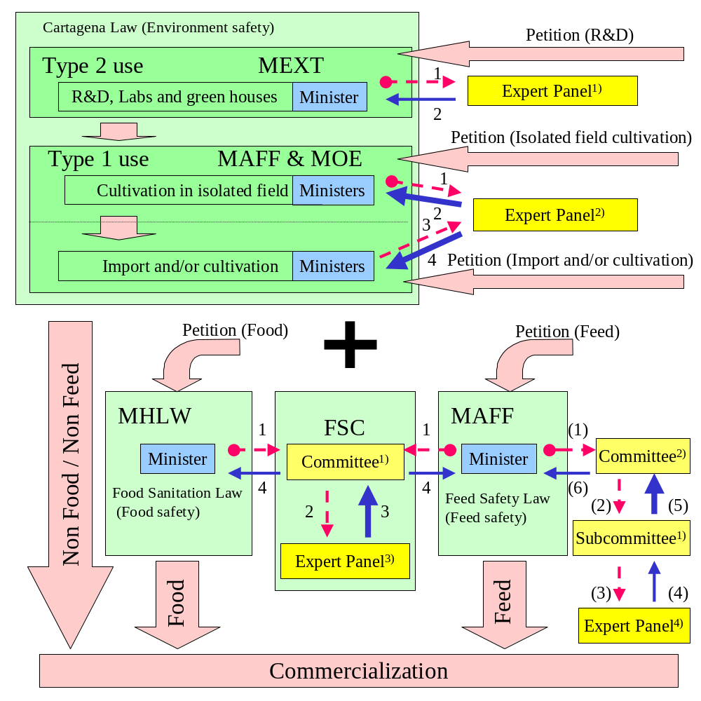
Expert Panel1): Expert Panel on Recombinant DNA Technology, Bioethics and Biosafety Commission, Council for Science and Technology, MEXT

Expert Panel2): Experts with special knowledge and experience concerning adverse effect on biological diversity selected by MAFF/MOE Ministers

Expert Panel3): Genetically Modified Foods Expert Committee, FSC

Expert Panel4): Expert Panel on Recombinant DNA Organisms, Agricultural Materials Council, MAFF

Committee1): Food Safety Commission

Committee2): Feed Committee, Agricultural Materials Council, MAFF
Subcommittee1): Safety Subcommittee, Feed Committee, Agricultural Materials Council, MAFF

Red (broken) arrow: Request for review or risk assessment
Blue (solid) arrow: Recommendation or risk assessment results (thick arrows: with public comment periods)
Numbers beside the arrows indicate the order of requests/recommendations within the respective ministries.

Petitions for products within the R&D stage are reviewed first for the Type 2 use under the Cartagena Law and those for import and/or cultivation (products in the R&D stage whose safety are already confirmed) are reviewed for the Type 1 use, and food and/or feed, as necessary. Petitions for products imported only as non-LMO such as processed foods are reviewed only for food and/or feed review.

This chart outlines principle flow of the approval procedure in Japan, and the process may vary depending on the nature of individual biotechnology products.

Approved biotechnology products

As of June, 2005, Japan has approved 61 biotech events for food, 38 for feed and 50 for planting. Until the Biosafety Protocol was ratified in November 2003, Japan had approved 106 events for import and 74 for planting. Those approvals expired when the new legal framework under the Biosafety Protocol was introduced except for those developers who requested to maintain the approvals temporarily. All products approved prior to the ratification of the Biosafety Protocol must be reviewed before being re-approved. Currently under the Biosafety Protocol, Japan does not grant separate environment approvals for import and planting.

Following list shows the status of the approvals.

List of Currently Approved Biotechnology Products in Japan
As of May 2005 (feed as of July 2003)
Plant species | Trait or Variety | Developer | Characteristics | Approvals
 |  |  |  | BSP (OECD UI) | Feed | Food
Canola | RT73 | Monsanto Japan | Herbicide tolerant | 2004* (MON-00073-7) | 1996 | 2001
 | HCN92 | Bayer Crop Science | Herbicide tolerant | 2004* (Topas19/2, ACS-BN007-1) | 1996 | 2001
 | HCN10 | Bayer Crop Science | Herbicide tolerant |  | 1998 | 2001
 | PGS1 | Bayer Crop Science | Herbicide tolerant | 2004* (ACS-BN004-7xACS-BN001-4) | 1996 | 2001
 | PHY14 |  |  |  | 1998 | 2001
 | PHY35 |  |  |  | 1998 | 2001
 | T45 | Bayer Crop Science | Herbicide tolerant | 2004* (ACS-BN008-2) | 1997 | 2001
 | PGS2 | Bayer Crop Science | Herbicide tolerant, male sterile, sterility recovery | 2004* (MS1RF2, ACS-BN004-7xACS-BN002-5) | 1997 | 2001
 | PHY36 |  |  |  | 1997 | 2001
 | PHY23 |  |  |  | 1999 | 2001
 | Oxy-235 | Bayer Crop Science | Herbicide tolerant | 2004* (ACS-BN001-5) | 1999 | 2001
 | MS8RF3 | Bayer Crop Science | Herbicide tolerant, male sterile, sterility recovery | 2004* (ACS-BN005-8xACS-BN003-6) | 1998 | 2001
 | MS8 | Bayer Crop Science | Herbicide tolerant, male sterile | 2004* (ACS-BN005-8) | 1999 | 2001
 | RF3 | Bayer Crop Science | Herbicide tolerant, sterility recovery | 2004* (ACS-BN003-6) | 1999 | 2001
 | RT200 | Monsanto Japan | Herbicide tolerant | 2004* (MON-89249-2) | 2001 | 2001
Plant species | Trait or Variety | Developer | Characteristics | BSP | Feed | Food
Carnation | 11 | Florigene/Suntory | Color change | 2004 (FLO-07442-4) | N/A | N/A
 | 123.2.38 | Florigene/Suntory | Color change | 2004 (FLO-40644-4) | N/A | N/A
 | 123.8.8 | Suntory | Color change | 2004 (FLO-40685-1) | N/A | N/A
 | 123.2.2 | Suntory | Color change | 2004 (FLO-40619-7) | N/A | N/A
 | 11363 | Suntory | Color change | 2004 (FLO-11363-1) | N/A | N/A
Corn | T-14 | Bayer Crop Science | Herbicide tolerant | 2004* (ACS-ZM-002-1) | 1997 | 2001
 | T-25 | Bayer Crop Science | Herbicide tolerant | 2004 (ACS-ZM003-2) | 1997 | 2001
 | MON810 | Monsanto Japan | Insect resistant | 2004 (MON-00810-6) | 1997 | 2001
 | Bt11 | Syngenta Seeds | Insect resistant | 2004* (SYN-BT011-1) | 1996 | 2001
 | Sweet corn, Bt11 |  |  |  | - | 2001
 | Event176 | Syngenta Seeds | Insect resistant | 2004* (SYN-EV176-9) | 1996 | 2001
 | CBH351 | Starlinc Logistic Inc. | Insect resistant, herbicide tolerant | 2004* | - | -
 | GA21 | Monsanto Japan | Herbicide tolerant | 2004* (MON-00021-9) | 1999 | 2001
 | DLL25 | Monsanto Japan | Herbicide tolerant | 2004* (DKB-89790-5) | 2000 | 2001
 | DBT418 | Monsanto Japan | Insect resistant, herbicide tolerant | 2004* (DKB-89614-9) | 2000 | 2001
 | NK603 | Monsanto Japan | Herbicide tolerant | 2004 (MON-00603-6) | 2001 | 2001
 | MON863 | Monsanto Japan | Insect resistant | 2004 (MON-00863-5) | 2002 | 2002
 | 1507 | DuPont | Insect resistant and herbicide tolerant | 2005 (DAS-01507-1) | 2002 | 2002
 | MON88017 | Monsanto Japan | Insect resistant, herbicide tolerant | 2004* (MON-88017-3) | - | -
 | MON863 x NK603 | Monsanto Japan | Herbicide tolerant, Insect resistant | 2004 (MON-00863-5xMON-00603-6) | - | 2003
 | GA21 x MON810 | Monsanto Japan | Herbicide tolerant, Insect resistant | 2004* (MON-00021-9xMON-00810-6) | - | 2003
 | MON810 x NK603 | Monsanto Japan | Herbicide tolerant, Insect resistant | 2004 (MON-00603-6xMON-00810-6) | - | 2003
 | MON810 x T25 | Monsanto Japan | Herbicide tolerant, Insect resistant | 2004* (ACS-ZM003-2xMON-00810-6) | - | 2003
 | 1507 x NK603 | DuPont | Herbicide tolerant, Insect resistant | 2005 (DAS-01507-1xMON-00603-6) | - | 2004
 | MON810 x MON863 | Monsanto Japan | Insect resistant | 2004 (MON-00810-6xMON-00863-5) | - | 2004
 | MON810 x MON863 x NK603 | Monsanto Japan | Herbicide tolerant, Insect resistant | 2004 (MON-00863-5xMON-00810-6xMON-00603-6) | - | 2004
Plant species | Trait or Variety | Developer | Characteristics | BSP | Feed | Food
Cotton | 531 | Monsanto Japan | Insect resistant | 2004 (MON-00531-6) | 1997 | 2001
 | 757 | Monsanto Japan | Insect resistant | 2005 (MON-00757-7) | 1997 | 2001
 | 1445 | Monsanto Japan | Herbicide tolerant | 2004 (MON-01445-2) | 1998 | 2001
 | 10211 | Monsanto Japan | Herbicide tolerant |  | - | 2001
 | 10215 | Monsanto Japan | Herbicide tolerant |  | 1998 | 2001
 | 10222 | Monsanto Japan | Herbicide tolerant |  | 1998 | 2001
 | 15985 | Monsanto Japan | Insect resistant | 2004 (MON-15985-7) | 2003 | 2002
 | 1445 x 531 | Monsanto Japan | Herbicide tolerant, Insect resistant | 2004 (MON-01445-2xMON-00531-6) | - | 2003
 | 15985 x 1445 | Monsanto Japan | Herbicide tolerant, Insect resistant | 2005 (MON-16985-7xMON-01445-2) | - | 2003
 | LLCotton25 | Bayer Crop Science | Herbicide tolerant |  | - | 2004
 | MON88913 | Monsanto Japan | Herbicide tolerant |  | - | 2005
 | MON88913 x 15985 | Monsanto Japan | Herbicide tolerant, Insect resistant |  | - | 2005
Papaya | 55-1 | Hawaii Papaya Ind. Assn. | Ringspot Virus resistant | 2004* | N/A | -
Plant species | Trait or Variety | Developer | Characteristics | BSP | Feed | Food
Potato | BT6 | Monsanto Japan | Insect resistant | Not needed | N/A | 2001
 | SPBT02-05 | Monsanto Japan | Insect resistant | Not needed | N/A | 2001
 | RBMT21-129 (NLP) | Monsanto Japan | Insect resistant and virus resistant | Not needed | N/A | 2001
 | RBMT21-350 (NLP) | Monsanto Japan | Insect resistant and virus resistant | Not needed | N/A | 2001
 | RBMT22-82 (NLP) | Monsanto Japan | Insect resistant and virus resistant | Not needed | N/A | 2001
 | SEMT15-15 (NLY) | Monsanto Japan | Insect resistant and virus resistant | Not needed | N/A | 2003
 | RBMT15-101 | Monsanto Japan | Insect resistant and virus resistant | Not needed | N/A | 2003
 | New Leaf Y Potato SEMT15-02 | Monsanto Japan | Insect resistant and virus resistant | Not needed | N/A | 2003
Soybean | 40-3-2 | Monsanto Japan | Herbicide tolerant | 2005 (MON-04032-6) | 1996 | 2001
 | 260-05 | DuPont | High oleic acid | 2004* (DD-026005-3) | 2000 | 2001
 | A2704-12 | Bayer Crop Science | Herbicide tolerant | 2004* (ACS-GM005-3) | 2003 | 2002
 | A5547-127 | Bayer Crop Science | Herbicide tolerant | 2004* (ACS-GM006-4) | 2003 | 2002
Sugar beet | T120-7 | Bayer Crop Science | Herbicide tolerant | Not needed | 1999 | 2001
 | 77 | Monsanto Japan | Herbicide tolerant | Not needed | 2003 | 2003
 | H7-1 | Monsanto Japan | Herbicide tolerant | Not needed | - | 2003
Number of total approvals |  |  |  | BSP | Feed | Food
 |  |  |  | 22 (28*) | 38 | 61
For each biotechnology variety, the years safety approvals were granted are shown for BSP environmental (import and planting), feed and food safety. ‘None‘ indicates the safety has not been confirmed by the Government of Japan. Potato and sugar beet are imported to Japan only as processed foods, thus indicated as ‘Not needed’ for import and planting. ‘N/A’ means not applicable. * in BSP approvals indicates temporary approvals until a full risk assessment is completed.

The list of approved events for food is also available on line from MHLW (http://www.mhlw.go.jp/english/topics/food/pdf/sec01.pdf).

Biotechnology products under field trials

The Japanese government requires all entities to obtain approval before performing field trials of biotech crops. The following table shows the list of those biotech crops currently in the field trial stage (extracted from Japan Biosafety Clearing House (J-BCH) website; http://www.bch.biodic.go.jp/english/lmo.html)

Approval Date | Name of the type of Living Modified Organism | Applicant
2004-06-11 | Semidwarf rice (OsGA2ox1, Oryza sativa L.) (G-3-3-22) | NIAS
2004-06-11 | Erect-leaved semidwarf rice) (ΔOsBRI1, Oryza sativa L.) (B-4-1-18) | NIAS
2004-06-11 | Tryptophan rich rice (OASA1D, Oryza sativa L.) (HW1) | NARO
2004-06-11 | Tryptophan rich rice (OASA1D, Oryza sativa L.) (HW5) | NARO
2005-04-25 | Rice tolerant to low iron availability (cry1Ac, Gossypium hirsutum L.) (gHvNAS1-1) | Tohoku University
2005-04-25 | Rice tolerant to low iron availability (HvNAAT-A, HvNAAT-B, Oryza sativa L.) (gHvNAAT1) | Tohoku University
2005-04-25 | Rice tolerant to low iron availability (HvIDS3, Oryza sativa L.) (gHvIDS3-1) | Tohoku University
2005-04-25 | Rice tolerant to low iron availability (HvNAS1, HvNAAT-A, HvNAAT-B, Oryza sativa L.) (gHvNAS1-gHvNAAT1) | Tohoku University
2005-04-25 | Rice tolerant to low iron availability (APRT,Oryza sativa L.) (I3pAPRT1) | Tohoku University
2005-04-25 | Rice tolerant to low iron availability (HvNAS1, HvNAAT-A, APRT, Oryza sativa L.) (I3pNasNaatAprt1) | Tohoku University
2005-05-25 | Rice producing Japanese cedar pollen allergy preventive peptide (DEF, Oryza sativa, L.) (7Crp#10) | NARO
2005-05-25 | Rice resistant to blast and bacterial leaf blight (DEF, Oryza sativa, L.) (AD41) | NARO
2005-05-25 | Rice resistant to blast and bacterial leaf blight (DEF, Oryza sativa, L.) (AD48) | NARO
2005-05-25 | Rice resistant to blast and bacterial leaf blight (DEF, Oryza sativa, L.) (AD51) | NARO
2005-05-25 | Rice resistant to blast and bacterial leaf blight (DEF, Oryza sativa, L.) (AD77) | NARO
2005-05-25 | Rice resistant to blast and bacterial leaf blight (DEF, Oryza sativa, L.) (AD97) | NARO
NIAS: National Institute of Agrobiological Sciences
NARO: National Agriculture and Bio-oriented Research Organization

Safety approvals of stacked events

Japan requires separate environment approvals for stacked events - those that combine two already approved traits, such as herbicide tolerance and insect resistance.

For environment safety approvals of stacked events, it is not always necessary to perform field trials. While MAFF and MOE require environment safety review by their experts, the data and information on the parents may be used and it is generally unnecessary to carry out field trials on the stacked events.

For food safety approvals, the FSC presented an opinion paper on January 29, 2004 on its reviews of crossed events between biotech and non-biotech events and stacked events. In this paper, the FSC categorized biotech events into three groups: 1) introduced genes which do not influence host metabolism and mainly endow the hosts with insect resistance, herbicide tolerance or virus resistance, 2) introduced genes which alter host metabolism and endow the hosts with high nutritional component concentration or suppression of cell wall degradation by promoting or inhibiting specific metabolic pathways, and 3) introduced genes which utilize certain metabolites to synthesize new metabolites the hosts originally do not produce.

The FSC requires a safety approval on the crossed event if the crossing occurs above the subspecies level between a biotech event and a non-biotech event, and if the crossing occurs biotech events in category 1. The FSC also requires safety approvals on stacked events between those in category 1 if the amount consumed by humans, the edible part or processing method is different from that of the parents. The FSC requires safety approvals on stacked events between biotech events in 1 and 2, 1 and 3, 2 and 2, 3 and 3, and 2 and 3. Most stacked events that result from traditional crossbreeding do not require a safety review.

For feed safety of stacked events, MAFF requires approvals from the Expert Panel on Recombinant DNA Organisms of the Agricultural Material Committee (AMC). Unlike the feed safety full approvals, the approvals by the Expert Panel are neither subject to MAFF Minister notification nor public comments.

National policy on coexistence between biotechnology and non-biotechnology plants

Japan, which produces no commercial biotech plants, has a guideline issued by MAFF on February 24, 2004, on field trials of biotech plants. Before field trials are performed, detail information including preventive measures for crossing with the same plant species in surrounding environment, such as buffer zones, must be made public on websites and through explanatory meetings for local residents.

The buffer zones should isolate the plants subject to field trials from the same plant species with a minimum distances stated below.

Name of the field tested plant | Minimum isolation distance
Rice | 26 meters (temporarily amended in April 2005 from 20 meters)
Soybean | 10 meters
Corn (applicable only on those with food and feed safety approvals) | 600 meters, or 300 meters with the presence of a windbreak
Rapeseed (applicable only on those with food and feed safety approvals) | 600 meters, or 400 meters if non-recombinant rapeseed is planted to flower at the same time of the field tested rapeseed. A width of 1.5 meters surrounding field tested plants as a trap for pollens and pollinating insects

If the field tested rice or soybeans have not received either food or feed approval, then, the same plant species should be planted as an index (index plant) to flower at the same time of the field tested plant to confirm if crossing took place between the inside and outside of the test field, and at least 10,000 seeds should be harvested (in the cases xenia is generated, seeds showing xenia are selected), and tested through analytical methods such as PCR that can specifically detect introduced genes of the field tested plant, or the presence of drug resistance if the introduction includes drug resistance, to confirm if crossing took place.

Following is a table of the range of “same plant species.”

Field tested plant | Plant belong to the same plant species
Rice (Oryza sativa L.) | Rice (Olyza sative L.)
Soybean (Glycine max L.) | Soybean (Glycine max L.)
Corn (Zea mays L.) | Corn (Zea mays L.) Teosinte (Zea mays subsp. Mexicana)
Rapeseed (Brassica napus) | Rapeseed (Brassica napus) Chinese cabbage, Radish, Komatsuna, Quing-geng-cai, Tsukena, etc. (Brassica rapa) Karashina, Takana, etc. (Brassica juncea) Kairan (Brassica alboglabra)
Tomato (Lycopsicum esculentum Mill.) | Tomato (Lycopsicum esculentum Mill.)
Cotton (Gossypium hirsutum L.) | Cotton (Gossypium hirsutum L.)
Alfalfa (Medicago sativa) | Alfalfa (Medicago sativa)
Potato (Solanum tuberosum) | Potato (Solanum tuberosum)

Local government regulations on coexistence

Hokkaido prefecture, which occupies the whole island of north Japan and is one of the major agricultural production areas, is planning to implement a prefecture law to regulate planting of biotech plants for field trial and commercial production. The law requires entities planning to carry out isolated field planting experiments, in addition to meeting the national government requirements, to report to the governor. The governor then asks prefecture’s food safety expert committee to examine the appropriateness of the experiments and if not approved the governor can order the entity to not carry out the experiments. The law also requires entities to obtain permission from the governor for any plans to release biotech products to the open environment as either field trials or commercial production. Violations of the prefecture law could result in imprisonment or a fine. The law was enacted to address the emotional concern over biotechnology as well as concerns from farmers that the presence of biotech crops could damage the image of their crops through consumer’s concern about commingling with biotech products. Some farmers in Hokkaido had planted test plots of biotech soybeans in the past, but this new law makes it unlikely that they will be able to continue.

Labeling policy for biotechnology products

MAFF and MHLW have implemented labeling requirements under the Food Sanitation Law and the Japan Agricultural Standards (JAS) Law, respectively for biotech products that have been approved in Japan. MAFF introduced the biotech labeling in response to a demand of “the consumers’ right to know” while MHLW introduced its labeling from a more scientific standpoint to clarify that the biotech ingredients used are those whose safety is confirmed. Although the labeling requirements for the Ministries are listed separately, both sets of requirements are basically identical. MAFF’s labeling policy on biotech traits may be found at the MAFF website (http://www.maff.go.jp/soshiki/syokuhin/hinshitu/organic/eng_yuki_gmo.pdf).

Both MAFF and MHLW biotech labeling schemes for non-biotech products are based on and rely on IP handling of non-biotech ingredients from production to final processing. The initial suppliers and operators of distribution of the products are responsible for supplying this certification to the exporter to Japan, who in turn supply its certification of IP handling in the U.S. to Japan’s food importers or manufacturers. The English version of the manuals for the IP handling of corn and soybeans, and potatoes are available at MAFF website (http://www.maff.go.jp/soshiki/syokuhin/hinshitu/e_label/file/Labeling/DistributionManu_SoyCorn.pdf ) and (http://www.maff.go.jp/soshiki/syokuhin/hinshitu/e_label/file/Labeling/DistributionManu_potato.pdf), respectively.

As shown below, the 30 foods currently subject to JAS labeling requirements (and MHLW labeling requirements) were selected because they are made from ingredients that could include biotech products and because traces of introduced DNA or protein can be identified in the foods. If the weight content of the ingredient to be labeled in these 30 foods exceeds 5 percent of total weight of the foods, they must be labeled with either the phrase "Biotech Ingredients Used" or "Biotech Ingredient Not Segregated" if the raw ingredient does not accompany certificates of the IP handling. In order to be labeled "Non-Biotech," the processor must be able to show that the ingredient to be labeled was IP handled from production through processing according to the above manuals.

Items subject to labeling | Ingredient to be labeled
- Tofu (soybean curd) and fried tofu  - Dried soybean curd, soybean refuse, yuba  - Natto (fermented soybean)  - To-nyu (soy milk)  - Miso (soybean paste)  - Cooked soybean  - Canned soybean, bottled soybean  - Kinako (roasted soybean flour)  - Roasted soybean  - Item containing food of items 1 to 9 as a main ingredient  - Item containing soybean (for cooking) as a main ingredient  - Item containing soybean flour as a main ingredient  - Item containing soybean protein as a main ingredient  - Item containing edamame (green soybean) as a main ingredient  - Item containing soybean sprouts as a main ingredient  - Corn snacks  - Corn starch  - Popcorn  - Frozen corn  - Canned or bottled corn  - Item containing corn flour as a main ingredient  - Item containing corn grits as a main ingredient  - Item containing corn (for processing) as a main ingredient  - Item containing food of items 16 to 20 as a main ingredient  - Frozen potato  - Dried potato  - Potato starch  - Potato snacks  - Item containing food of items 25 to 28 as a main ingredient  - Item containing potato (for processing) as a main ingredient | Soybean  Soybean  Soybean  Soybean  Soybean  Soybean  Soybean  Soybean  Soybean  Soybean  Soybean  Soybean  Soybean  Edamame  Soybean sprouts  Corn  Corn  Corn  Corn  Corn  Corn  Corn  Corn  Corn  Potato  Potato  Potato  Potato  Potato  Potato
Note: As of July 2005, labeling on alfalfa products is under consideration as biotech alfalfa events are nearing the end of the approval process.

In addition to the 30 food items in the table, Japan applies the biotech labeling on the biotech high oleic acid soybean products even though the oil extracted from the soybean does not contain traces of the introduced genes or proteins.

Monitoring of “Biotechnology” or “Non-biotechnology” labeled foods

Japan recognizes that even though proper IP handling and distribution methods are used, the possibility exists for adventitious commingling of biotech products in non-biotech products. Therefore, for corn and soybeans, Japan set an informal tolerance of 5% for biotech ingredients in products that are labeled "non-biotech." This tolerance only applies to events that have been approved in Japan. If MAFF or MHLW finds a product labeled "non-biotech" that has a biotech (corn and soybeans) content of over 5 %, it is determined that the IP handling had not been carried out adequately. The ministry orders the manufacturer or importer to present the IP handling certificates to verify them and issues guidance directing it to correct the product’s label to show that it was made with "Biotech Ingredients."

Monitoring for unapproved biotechnology events

Like the United States, Japan has a zero tolerance for unapproved biotech events in foods. To assure compliance, a sampling program is in place to test both import shipments and processed food products at the retail level. Any detection of an unapproved biotech event in a food is deemed a violation of Japan’s Food Sanitation Law. As a part of the monitoring program for imported foods, testing at ports is handled by MHLW directly, while local health authorities handle testing for processed foods at the retail level. All testing is performed according to sampling and testing criteria set by MHLW. If the detection is at the port, the shipment must be re-exported, destroyed or diverted for non-food use. If the detection is at the retail level, the manufacturer of the product must issue an immediate recall. The main products currently being tested are corn, soybeans, papayas, and potatoes.

Under the Feed Safety Law, MAFF monitors quality and safety of imported feed ingredients at the ports. All biotech derived plant materials to be used as feed in Japan must obtain approvals for feed safety from MAFF. However, as an exemption from the regulation, MAFF has set a 1% tolerance for the unintentional commingling of biotech products in feed that are approved in other countries but not yet approved in Japan. To apply the exemption, the exporting country must be recognized by the MAFF minister as having a safety assessment program that is equivalent to or stricter than that of Japan.

Implementation of requirements for export of biotechnology products (living modified organisms, LMOs) under the Biosafety Protocol

After it ratified the Biosafety Protocol in November 2003, Japan implemented the “Law Concerning the Conservation and Sustainable Use of Biological Diversity through Regulations on the Use of Living Modified Organisms” on February 19, 2004. Although the details on how to implement the requirements of the first sentence of paragraph 2(a) of Article 18 of the Protocol on export of LMOs have not been determined yet, Japan presented its view on compliance to the requirements in November 2004 at a workshop in Bonn.

For export of LMOs directly used for food, feed and processing (FFP), Japan proposed that the Parties shall attach the following information along with the form prescribed by the Regulations related to the Enforcement of the Law or its package/container or consignment invoice when LMOs for FFP is exported; “the LMOs 1) “may contain” living modified organisms, 2) are not intended for intentional introduction into the environment, and 3) accompany information on contact point (name, address, contact details of the exporter and importer)”.

At the workshop, Japan, as an importing Party, stated that it does not have any threshold levels for unapproved LMOs, and it does not feel it sis necessary to set an international standard for threshold levels of approved LMOs. Further, individual parties based on their own labeling requirements and consumer interests, etc must determine these threshold levels.

Japan stated it is necessary to use the “may contain” language if there is a possibility of unintentional commingling of LMOs in a non-LMO FFP cargo, but it is not necessary to have specific documentation supporting this claim when the degree of the commingling meets the acceptable levels determined independently by the importing Parties. Japan recommended to adopt the unique identifier of OECD because it assures the access to the necessary information through Biosafety Clearing House (BCH).

SECTION IV. MARKETING ISSUES

Although the food industry and the government are generally receptive of agricultural biotech products, they are cautious about publicly discussing their benefits. Consumer concerns, particularly among some small but very vocal consumer associations, have been strong since biotech products were put on the market in late 1990’s. As a result, the food industry is very hesitant to even attempt to provide a biotech product to the consumer. In fact, out of a fear of a consumer backlash, retailers, particularly large supermarket chains, demanded the food industry to supply non-biotech foods - even for products that do not have to be labeled, which in turn resulted in procurement of non-biotech raw ingredients by importers. This tendency for demanding non-biotech ingredients is particularly strong for foods made from soybeans such as soy sauce, tofu, miso and natto, and snack foods using corn but also extends to corn starch and beverages using these ingredients such as beer. Many retailers use the consumer concerns to their advantage by marketing their in-house products as “safer” and “more natural” than those provided by their competitors.

The retailer’s hesitancy to provide a biotech product reinforces the consumer’s perception that there is something wrong in biotech foods, which in turn further strengthens the perceived marketing advantage in providing non-biotech products. Once a biotech product that has clear consumer advantage or meets consumer needs is put on the market, this vicious cycle may be terminated.

The Food Safety Commission did a survey on food safety in 2003 and the report is available in English (http://www.fsc.go.jp/english/monien_sum0309.pdf). The survey targeted ‘food safety monitors’ who provide suggestions and opinions to the FSC on its policy; therefore, the participants are people who are more concerned about food safety than the average person (see the demographic profile below). The survey found that about a half of the responders were concerned about the safety of biotech foods.

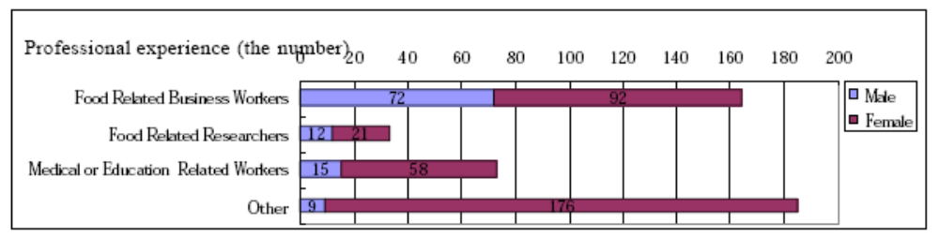

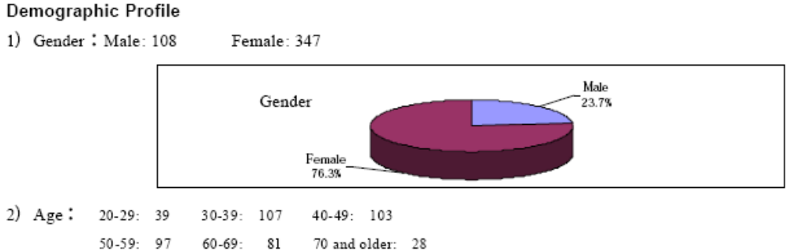

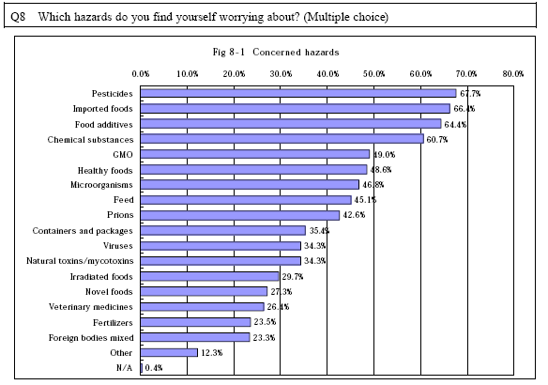

There is also a survey of 500 attendees of an Agriculture Festival in Tokyo by Society for Techno-Innovation of Agriculture, Forestry and Fisheries (STAFF), a quasi-MAFF organization funded by MAFF and the agricultural technology industry which helps to promote agricultural biotech research and public acceptance.

The survey shows that the Japanese receive information on agricultural biotechnology mainly through newspapers and TV, and around a half of the information is negative. The survey indicated that over a half of the people feel the entities involved in agricultural biotechnology are not transparent. The survey suggests that it is important to proactively provide accurate and objective information on agricultural biotechnology to the media including newspaper and TV stations.

Information contents on agricultural biotechnology are:

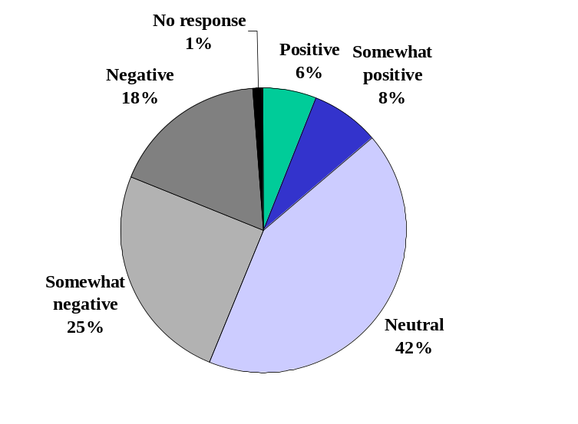
Source: STAFF survey, March 2005

Information source on agricultural biotechnology:

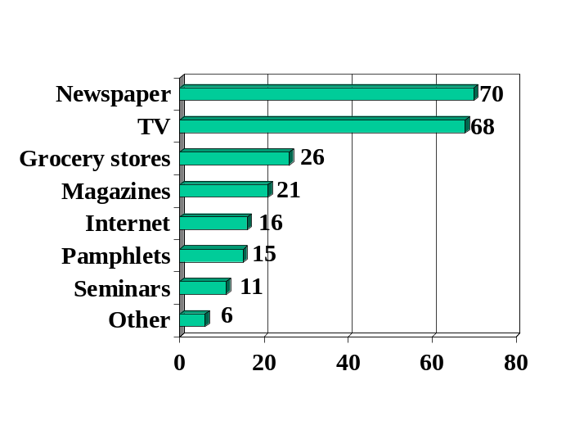

Source: STAFF survey, March 2005
The STAFF survey also shows the people are more willing to accept and buy nutritionally enhanced or disease preventive biotech products than products with just a price or production advantages. The results suggest that the key for acceptance of biotech products is to have products with clear consumer advantages or that meet consumer needs.

Which approved biotech products would you buy
if they are put on the shelf of retail shops as all other foods do?

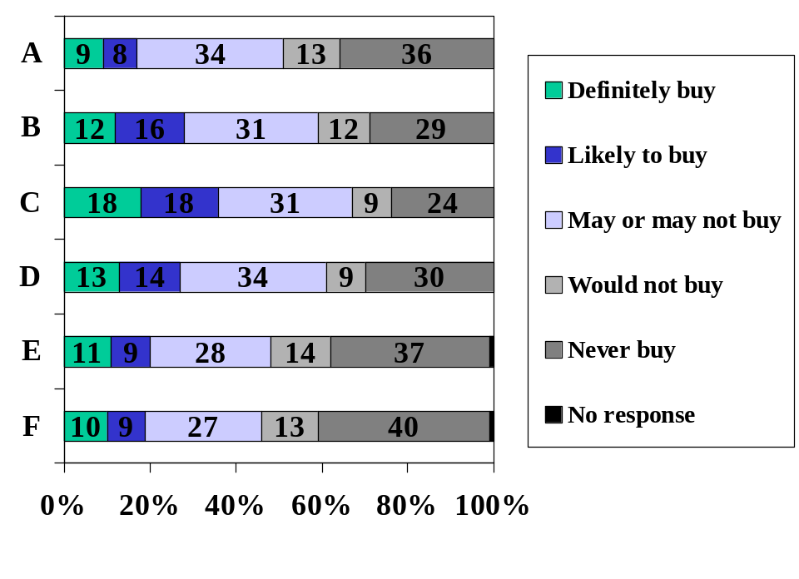
A: Biotech foods with no particular characteristics at the same price
B: Better taste biotech foods at the same price
C: Disease (pollen allergy or diabetes) preventive biotech foods at the same price
D: Nutritionally enhanced (iron or mineral rich) biotech foods at the same price
E: Herbicide tolerant biotech foods with 20 % lower price
F: Herbicide tolerant biotech foods with 10 % lower price

Source: STAFF survey, March 2005
Public Acceptance of Agricultural Biotech Products
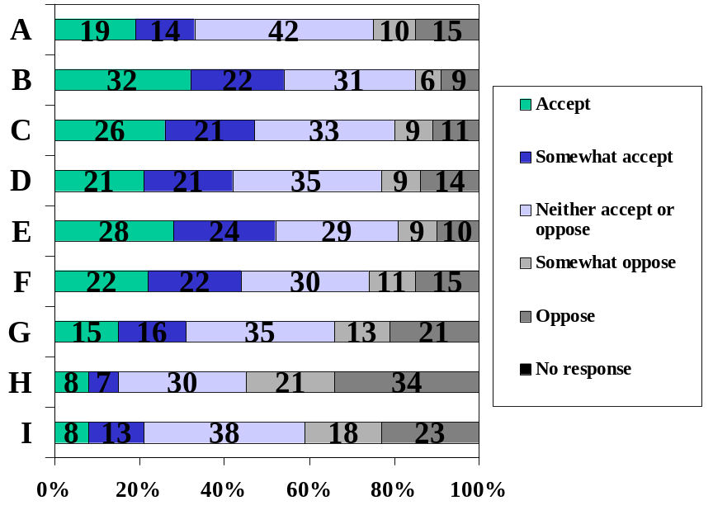
I will accept agricultural biotech if the following products are put on the market:

A: Agricultural biotech products to be used for beneficial substance production
B: Agricultural biotech products to prevent desertification
C: Agricultural biotech products for environment remediation
D: Agricultural biotech products to produce pharmaceutical products including edible vaccines
E: Agricultural biotech products medically effective in disease prevention
F: Agricultural biotech products contributing to health promotion
G: Agricultural biotech products with better taste
H: Agricultural biotech products with herbicide tolerance for easier cultivation
I: Agricultural biotech products with insect resistance for easier cultivation

Source: STAFF survey, March 2005

SECTION V. CAPACITY BUILDING AND OUTREACH

In March 2004, FAS Tokyo carried out a seminar program by the American Farm Bureau Federation including its chairperson Bob Stallman in four cities in Japan, in cooperation with local American Consulate and American Centers. The seminars, entitled “Agricultural Production and Biotech Crops - A Look at Environment Benefits” were held in Fukuoka, Osaka and Sapporo besides Tokyo. Around 200 academics, and industry and consumer representatives attended the seminars. FAS Tokyo invited Japanese farmers to present their views on biotech products and their benefits in production as part of the seminars. AFBF explained the “win-win (for consumers and producers)” benefits of biotech products, through prevention of surface soil erosion by no-till farming and reduction of frequency of pesticide spray that enables environment-friendly agriculture and allows less works and cost reduction by reducing frequency of pesticide sprays. Japanese farmers presented their experiences of growing herbicide tolerant biotech soybeans.

In August 2004, FAS Tokyo organized a tour by a Japanese team of three farmers, one college professor, four reporters and one non-governmental organization representative to the U.S. They visited the U.S. to look at the use of biotech in the U.S. The team saw biotech papaya production in Hawaii and had direct communications with growers and a grocery store producing and selling the biotech papayas. The team also visited several farmers in the Midwest to see the benefits of no-till farming and how crops developed through biotechnology reduces labor, increase yield and require less pesticides. They visited a biotechnology developer laboratory, a public laboratory of plant biotechnology and finally met with representatives of USDA, the U.S. Congress, the private sector, non-profit organizations and trade associations in Washington, D.C. FAS Tokyo created a 20 minute-video on the benefits of biotechnology based on the trip scenes, which will be distributed to the media and various organizations to promote understanding on agricultural biotechnology.

FAS Tokyo hosted Dr. James Maryanski as an Embassy Science Fellow, a Department of State visitor program for technical experts in the fall of 2004. Dr. Maryanski stayed in Japan for 8 weeks to exchange opinions, provide information and speak at seminars on not only biotech but also overall food risk assessment and communication. Dr. Maryanski met with officials from MAFF, MHLW and FSC, leading scientists in biotech, Japanese food industry representatives, consumer group leaders and media reporters. Dr. Maryanski spoke at seminars organized by FAS and Consulates/American Centers in Tokyo, Osaka and Nagoya, with an audience of around 200 in total. During his visit to Japan, Dr. Maryanski successfully conveyed information on the science-based approach to the safety of biotech foods in the U.S.

SECTION VI. REFERENCE MATERIALS

Following is a list of website of information on agricultural biotechnology and biotech foods in English. Please note that this information is not necessarily current and you may need to download the Japanese Language Package to read the pdf files even if they are written in English.

Food Safety Commission (biotech food risk assessment standards)
http://www.fsc.go.jp/senmon/idensi/gm_kijun_english.pdf

Ministry of Agriculture, Forestry and Fisheries (Information related to agricultural biotechnology)
http://www.s.affrc.go.jp/docs/sentan/

Ministry of Health, Labor and Welfare (Information related to biotech food regulations)
http://www.mhlw.go.jp/english/topics/food/index.html

(Information on biotech food labeling)
http://www.mhlw.go.jp/english/topics/qa/gm-food/index.html

Biosafety Clearing House
http://www.bch.biodic.go.jp/english/e_index.html

